As per LGDCode mapping on Jal Rekha Portal
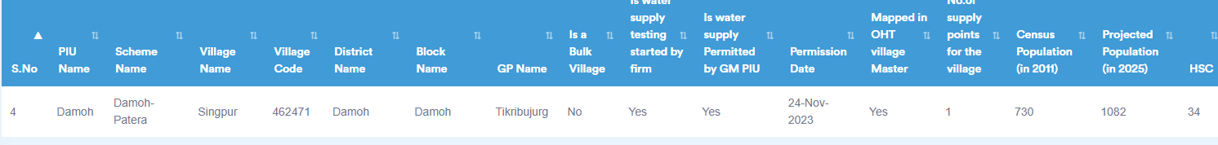
As per IMIS JJM Portal

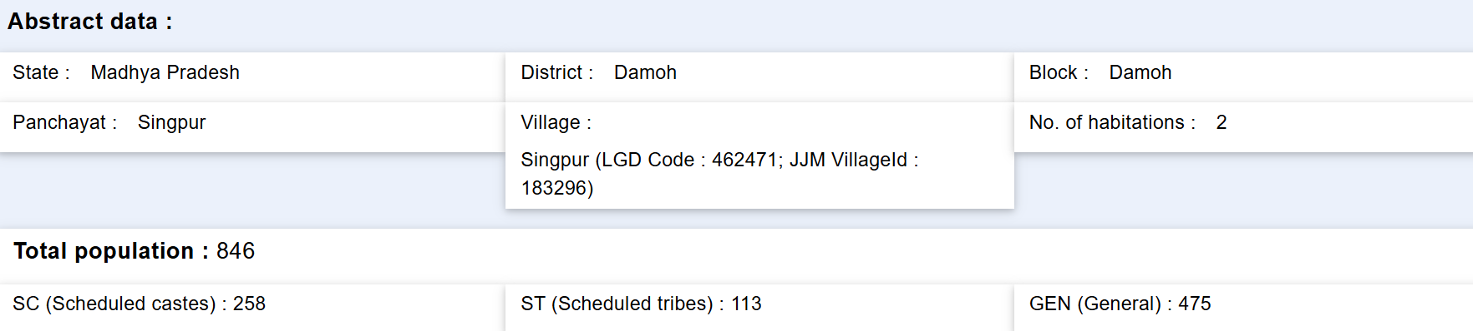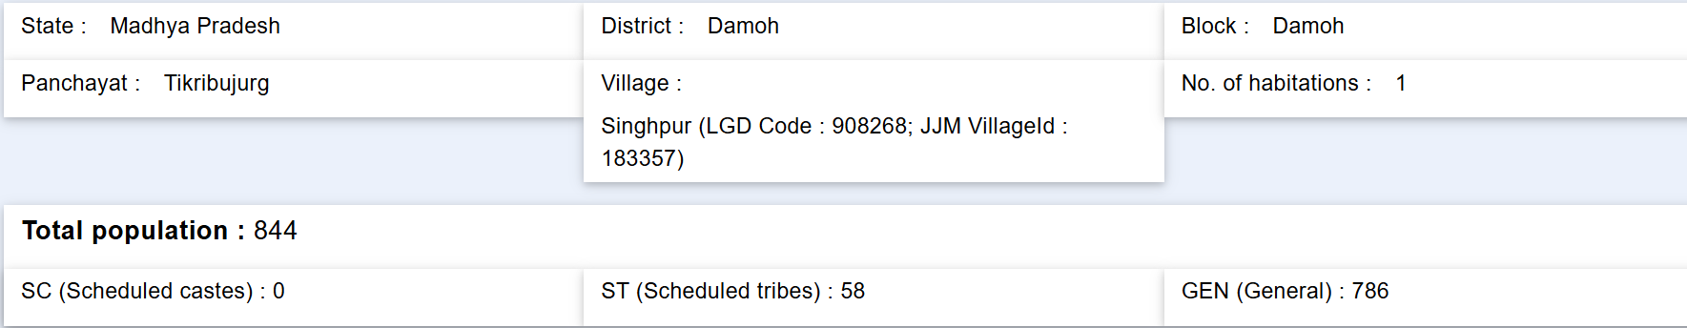
Mapped with Damoh Patera
Mapped with Bebus Sunar-2

